Working with tools in the Maker Space is an important part of engineering. You will need to be certified in each of the green tools card listed below.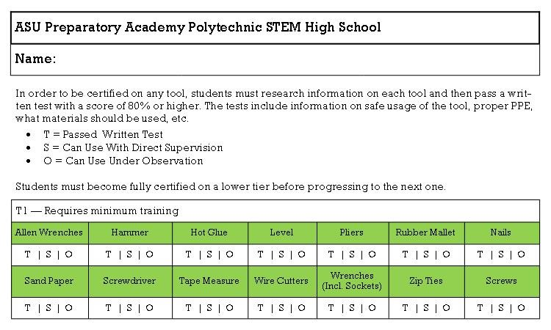
To become certified you must pass a written exam and show me that you can use the tools listed properly. We will be spending the next week researching each tool and presenting the proper way to use the given tools and what they are used for.
You and a partner will pick a tool to research. You will create a powerpoint, poster, or some visual aid that you present to the class. Each presentation should last no more than 10 minutes. Your presentation should include the following:
- Introduction
  - What the tool is.
- Body
  - How to use the tool.
  - What the tool is used for. (Give examples)
  - Do’s and Don’ts.
- Conclusion
  - Summary.
  - Check for understanding. (Make this interesting and fun! Preferably a game!)
You will not be able to start the first project until you have passed the written test for the green tools. So it is important to finish this presentation project in a timely manner. You do not want to be behind the first project.
The powerpoint, poster, or visual aid needs to be shared with me by August 2, 2019. My email is jjaegerasuprep.weebly.com. The rubric is on the back of this page.

Category | 4 points | 3 points | 0-2 points
Introduction  -Explains what the tool is | Fully addressed all criteria | Partially addressed the criteria | Minimally addressed the criteria
Visual aid  -Images of the tool and where it is used  -Appealing | Fully addressed all criteria | Partially addressed the criteria | Minimally addressed the criteria
Body  - Do’s and Don’ts  - How to use the tool  - Where the tool is used | Full addressed all criteria | Partially addressed the criteria | Minimally addressed the criteria
Conclusion  - Summary  - Check for understanding | Fully addressed all criteria | Partially addressed the criteria | Minimally addressed the criteria
Total points

